1. What Problem Did I Fix?
In Code-A:
- Every time someone asked for data, the server downloaded the entire CSV file from the internet.
- It sent back all 5,000+ rows as plain text (like a big Excel file). This is slow and wastes bandwidth.
In Code-B:
- I made the server smarter and faster. Now it:
  - Downloads the CSV only once (not every time).
  - Lets you search and paginate the data (like Google search results).
  - Returns a lightweight JSON response (easy for apps to use).

2. Key Changes I Made
A. Caching the Data
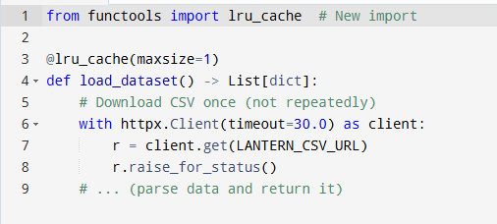
- Why?
  - Old code (Code-A) downloaded the CSV every time. Slow!
  - Code-B downloads it once, then reuses it. Super-fast!
- Benefit: Reduces server load + faster responses.

B. Pagination & Search
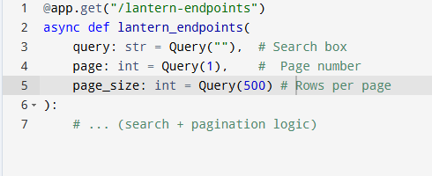
- Why?
  - Humans can’t read 5,000 rows at once.
  - Now you can:
    - Search by URL/name (e.g., query=hospital).
    - Paginate results (e.g., page=2, pageSize=100).
- Benefit: Easier to use + mobile-friendly.

C. Filtered & Structured Response
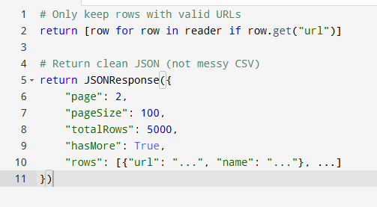
- Why?
  - Code-A returned raw CSV (hard to read).
  - Code-B returns organized JSON:
    - Only useful fields (url, name).
    - Metadata like totalRows and hasMore.
- Benefit: Apps use this data easily.

D. Error Handling
- Both codes handle download errors (e.g., if the CSV server is down).
- Code-B adds extra safety:
  - Timeout (timeout=30.0) to avoid hanging.
  - Filters invalid rows (no url).

3. Necessary Imports Added
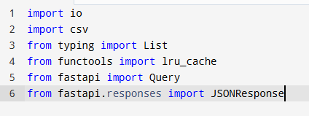
- Why?
  - io + csv: Parse CSV text → Python dictionaries.
  - lru_cache: Remember the downloaded data.
  - Query: Enable search/pagination parameters.
  - JSONResponse: Send tidy JSON (not CSV).

5. Why Is This Better?
Why Each Change Matters (In Plain Words)
- Caching with @lru_cache
We fetch the CSV only once. After that, every user call just reads the data already in memory. This is kinder to the remote server and speeds up your API.
- CSV → DictReader → JSON
Raw CSV is hard for most web pages to chew. Converting to dictionaries then to JSON means JavaScript (or any client) uses the data right away.
- Search (query)
Instead of downloading 50 000 rows and sifting on the front-end, the server does the search. The result arrives ready-filtered.
- Paging (page, pageSize)
Mobile phones and browsers like small bites of data. Paging keeps responses quick and smooth.
- Simple Field List (url, name)
Many original columns are rarely used. Sending only the key parts keeps payloads tiny.
- Soft Limits
PAGE_SIZE_MAX = 1000 stops someone from asking for too many rows in one hit, protecting your server.

Feature | Code-A (Old) | Code-B (New)
Speed | Slow (downloads every time) | Fast (caches data)
Data Size | Huge (all rows) | Small (paginated)
Usability | Raw CSV (hard to use) | JSON + search (easy)
Server Load | High (no cache) | Low (cache + pagination)

